
Trinity Evangelical Lutheran Church

502 Bardshar Road

Sandusky, OH 44870

419-626-0204

Sunday, September 13th, 2026

100th Anniversary Service

Prelude

Welcome and Announcements

Confession and Forgiveness
Blessed be the holy Trinity, ☩ one God,
who pours love into our hearts
and healing upon the earth. Amen.

Confident that God justifies us by grace through faith,
let us confess our sin.

Compassionate God,

We confess that we struggle to embody your goodness
in the world and in our own hearts.
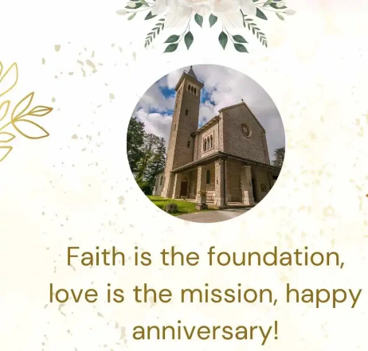
Creation groans from overuse.
Jealousy and bitterness strain our relationships.
Indifference keeps us from seeking justice.
Divisions disrupt your call to show genuine love
to others.

Turn our hearts back to you.
Restore our world and reconcile us to one another.
Renew us to live as your holy people,
following the way of Jesus Christ. Amen.

Hear this good news:
We have peace with God through ☩ Jesus Christ,
in whom there is no condemnation,
but only forgiveness and the promise of eternal life.
Receive freely this healing gift of grace. Amen.

Opening Hymn:
Holy, Holy, Holy, Lord God Almighty! No. 413

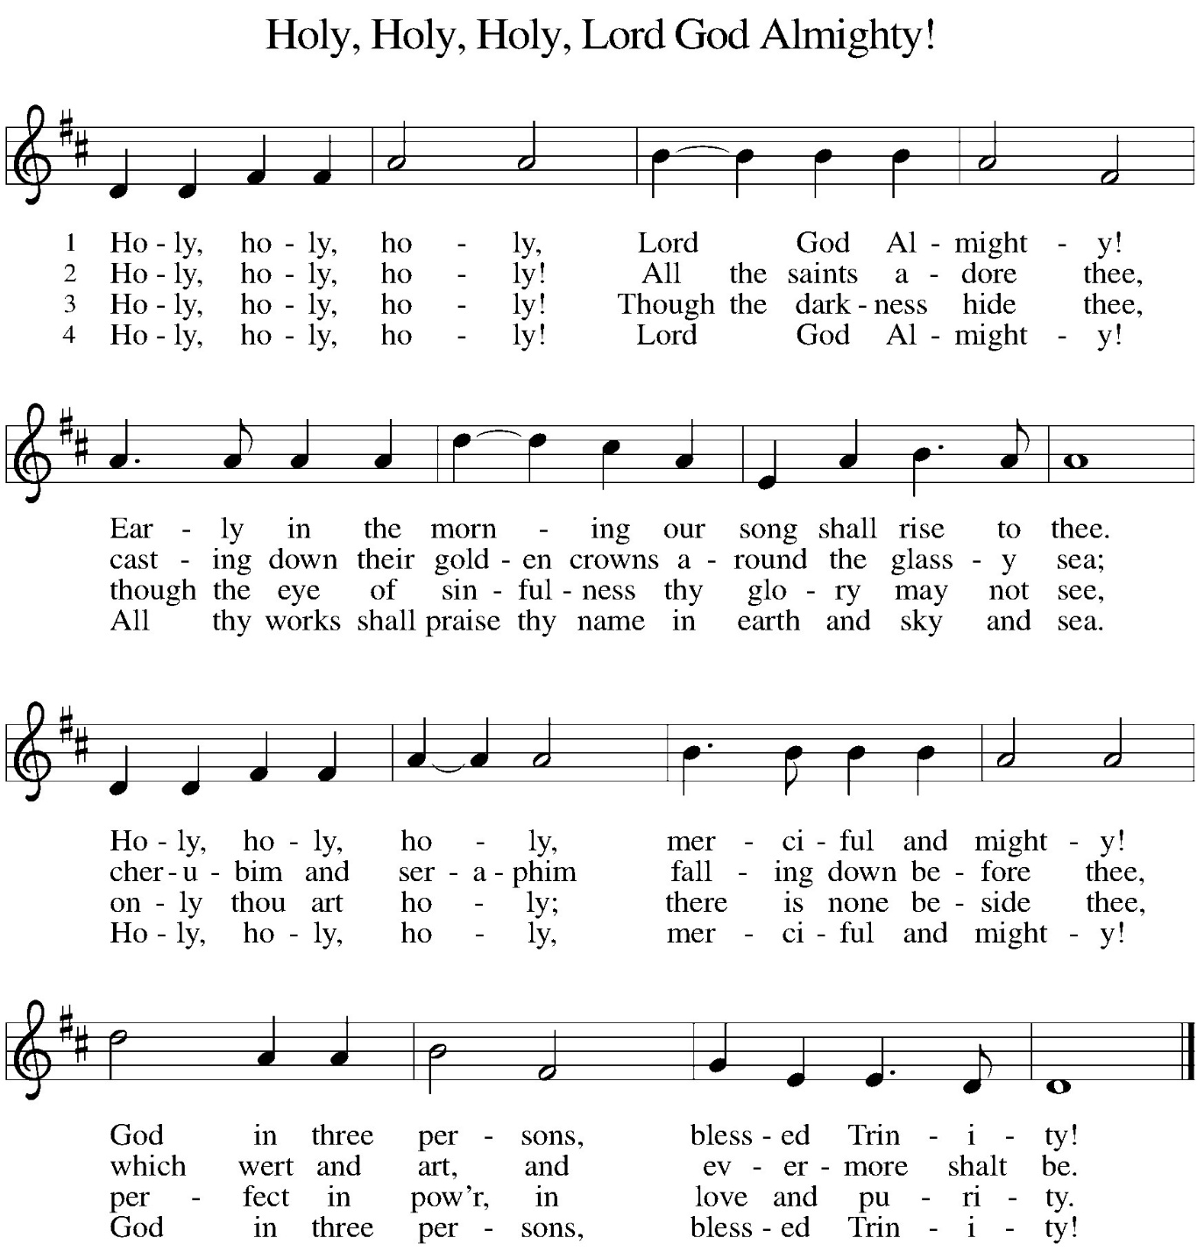
Greeting
The grace of the Lord Jesus Christ, the love of God,
and the communion of the Holy Spirit be with you all.
And also with you.

Prayer of the Day

O God, you have promised through your Son to be with your church forever. We give you thanks for those who founded this community of believers and for the signs of your presence in our congregation. Increase in us the spirit of faith and love and make our fellowship an example to all believers and to all nations. We pray through Jesus Christ, our Savior and Lord, who lives and reigns with you and the Holy Spirit, one God, now and forever. Amen.

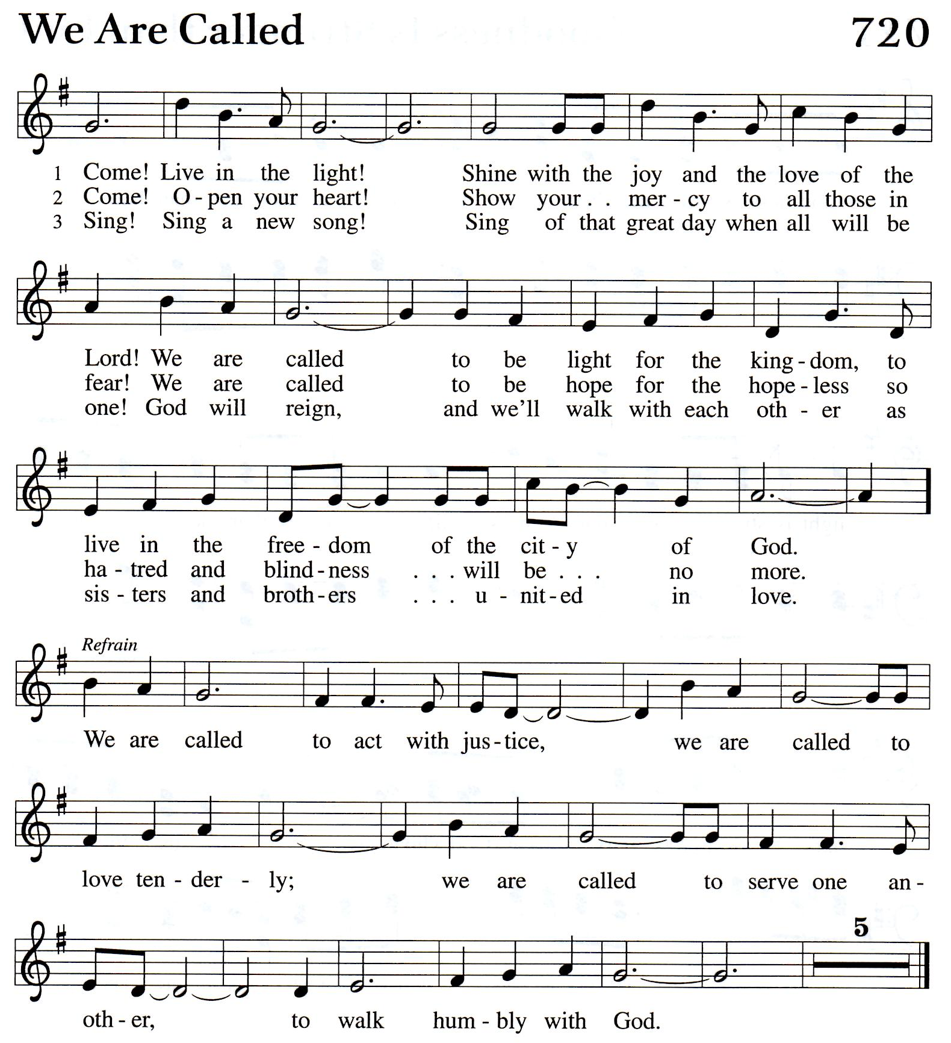
Hymn of the Month: We Are Called No. 720

Special Music: This is My Prayer Chime Players

First Reading: 1 Kings 8:22-30

²² Then Solomon stood before the altar of the Lord in the presence of the whole assembly of Israel and spread out his hands to heaven. ²³ He said, “O Lord, God of Israel, there is no God like you in heaven above or on earth beneath, keeping covenant and steadfast love with your servants who walk before you with all their heart, ²⁴ the covenant that you kept for your servant my father David as you declared to him; you promised with your mouth and have this day fulfilled with your hand. ²⁵ Therefore, O Lord, God of Israel, keep for your servant my father David that which you promised him, saying, ‘There shall never fail you a successor before me to sit on the throne of Israel, if only your children look to their way, to walk before me as you have walked before me.’²⁶ Therefore, O God of Israel, let your word be confirmed that you promised to your servant my father David.
²⁷ “But will God indeed dwell on the earth? Even heaven and the highest heaven cannot contain you, much less this house that I have built! ²⁸ Regard your servant’s prayer and his plea, O Lord my God, heeding the cry and the prayer that your servant prays to you today, ²⁹ that your eyes may be open night and day toward this house, the place of which you said, ‘My name shall be there,’ that you may heed the prayer that your servant prays toward this place. ³⁰ Hear the plea of your servant and of your people Israel when they pray toward this place; O hear in heaven your dwelling place; hear and forgive.
Word of God, word of life. Thanks be to God.

Psalm: 84

¹ How lovely is your dwelling place, O Lord of hosts!
² My soul longs, indeed it faints,
for the courts of the Lord;
my heart and my flesh sing for joy to the living God.
³ Even the sparrow finds a home
and the swallow a nest for herself,
where she may lay her young,
at your altars, O Lord of hosts, my King and my God.
⁴ Happy are those who live in your house,
ever singing your praise.
⁵ Happy are those whose strength is in you,
in whose heart are the highways to Zion.
⁶ As they go through the valley of Baca,
they make it a place of springs;
the early rain also covers it with pools.
⁷ They go from strength to strength;
the God of gods will be seen in Zion.
⁸ O Lord God of hosts, hear my prayer; give ear, O God of Jacob!
⁹ Behold our shield, O God;
look on the face of your anointed.
¹⁰ For a day in your courts is better than a thousand elsewhere.
I would rather be a doorkeeper in the house of my God
than live in the tents of wickedness.
¹¹ For the Lord God is a sun and shield; he bestows favor and honor.
No good thing does the Lord withhold
from those who walk uprightly.
¹² O Lord of hosts, happy is everyone who trusts in you.

Second Reading: 1 Peter 2:1-9
¹ Rid yourselves, therefore, of all malice and all guile, insincerity, envy, and all slander. ² Like newborn infants, long for the pure, spiritual milk, so that by it you may grow into salvation—³ if indeed you have tasted that the Lord is good.
⁴ Come to him, a living stone, though rejected by mortals yet chosen and precious in God’s sight, and ⁵ like living stones let yourselves be built into a spiritual house, to be a holy priesthood, to offer spiritual sacrifices acceptable to God through Jesus Christ. ⁶ For it stands in scripture: “See, I am laying in Zion a stone, a cornerstone chosen and precious, and whoever believes in him will not be put to shame.”⁷ This honor, then, is for you who believe, but for those who do not believe, “The stone that the builders rejected has become the very head of the corner,” ⁸ and “A stone that makes them stumble and a rock that makes them fall.” They stumble because they disobey the word, as they were destined to do.
⁹ But you are a chosen people, a royal priesthood, a holy nation, God’s own people, in order that you may proclaim the excellence of him who called you out of darkness into his marvelous light.

Word of God, word of life. Thanks be to God.

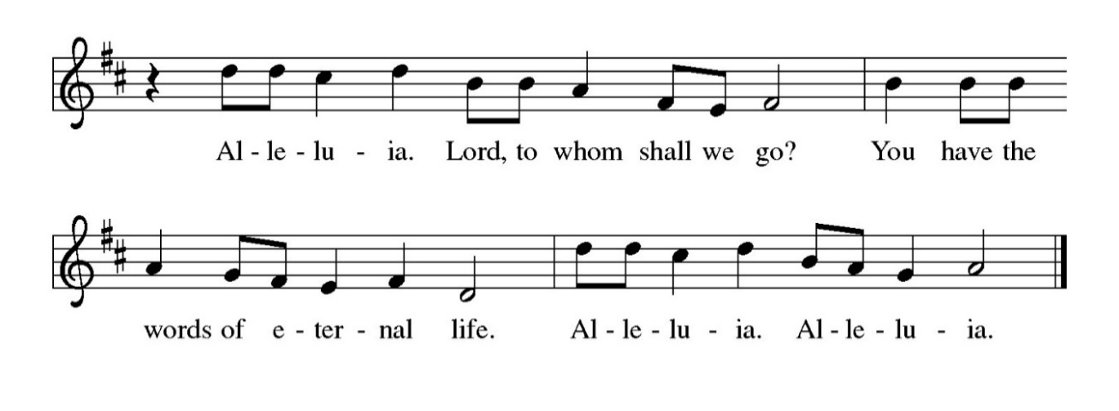
Gospel Acclamation

Gospel: John 10:22-30
The holy gospel according to John, Glory to you, O Lord.

²² At that time the Festival of the Dedication took place in Jerusalem. It was winter, ²³ and Jesus was walking in the temple, in the portico of Solomon. ²⁴ So the Jews gathered around him and said to him, “How long will you keep us in suspense? If you are the Messiah, tell us plainly.” ²⁵ Jesus answered, “I have told you, and you do not believe. The works that I do in my Father’s name testify to me, ²⁶ but you do not believe because you do not belong to my sheep. ²⁷ My sheep hear my voice. I know them, and they follow me.
²⁸ I give them eternal life, and they will never perish. No one will snatch them out of my hand. ²⁹ My Father, in regard to what he has given me, is greater than all, and no one can snatch them out of the Father’s hand. ³⁰ The Father and I are one.”
The gospel of the Lord. Praise to you, O Christ.
Children’s Message

Sermon Bishop Daniel Beaudoin

Hymn of the Day: The Church’s One Foundation
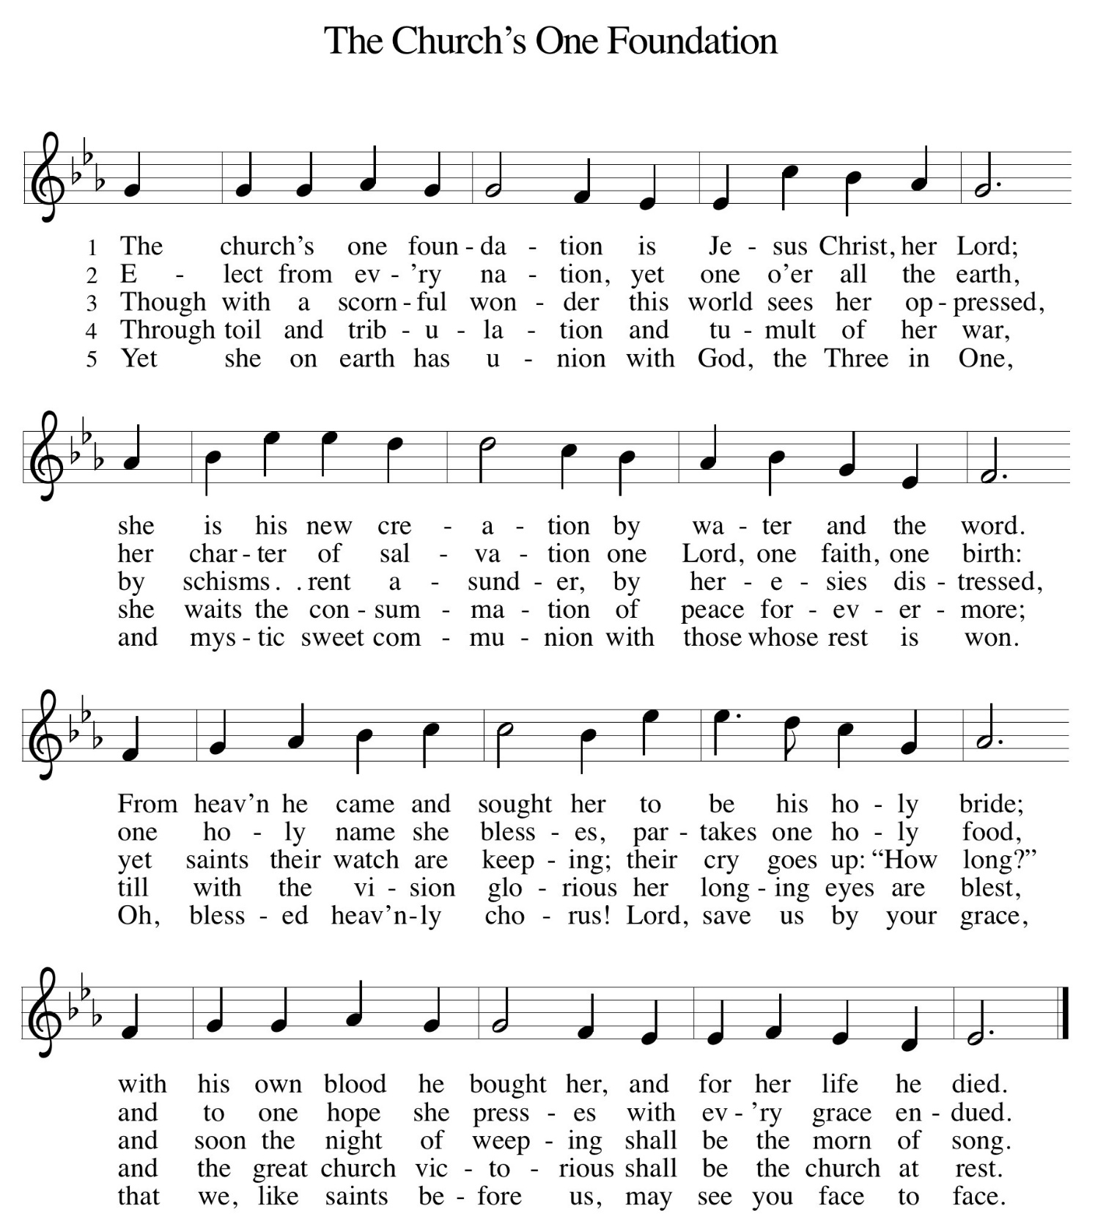

Apostles’ Creed
I believe in God, the Father Almighty, Creator of heaven and earth.
I believe in Jesus Christ, God’s only Son, our Lord, who was conceived by the Holy Spirit, born of the virgin Mary, suffered under Pontius Pilate, was crucified, died, and was buried; he descended to the dead.
On the third day he rose again; he ascended into heaven, he is seated at the right hand of the Father, and he will come to judge the living and the dead. I believe in the Holy Spirit, the holy catholic church, the communion of saints, the forgiveness of sins, the resurrection of the body, and the life everlasting. Amen.

Prayers of Intercession
Reminded of God’s gracious and abundant love, we offer our prayers, confident that God hears us.
Move your church throughout the world away from judgement, fear, and hate. Lead us to embody the forgiveness, love, and joy you have given us in Jesus. Hear us, O God. Your mercy is great.

The endless beauty of your creation reminds us of your mercy. Protect those who care for farms, fields, animals: domestic and wild. Guide those who lead us to wonder at your creation. Hear us, O God. Your mercy is great.

Raise up leaders like the brave and believing people who began this congregation. We give thanks for those who have served as pastor, musician, council, and ministry partners in the past and ask your blessing on those who continue now and in the future. Hear us, O God. Your mercy is great.

Calm the fears of all in need with your promises. Bring healing to those who are ill, rest to those who are weary, strength to those who are grieving, and peace to all who call on you. Hear us, O God. Your mercy is great.

Ground this congregation in your amazing love that spans the centuries. Inspire each of us to welcome, love and serve others in your name. Hear us, O God.
Your mercy is great.

With you is found the joy and promise of eternal life. Keep us in that joy as we remember all those who have gone before us. Hear us, O God. Your mercy is great.

In your great mercy, hear the prayers we have offered, aloud and in the depths of our hearts. We trust your answer for all we ask in Jesus’ name. Amen.

Offertory (Ushers please bring the offering to the altar)

Offertory Song: Jesus, the Very Thought of You
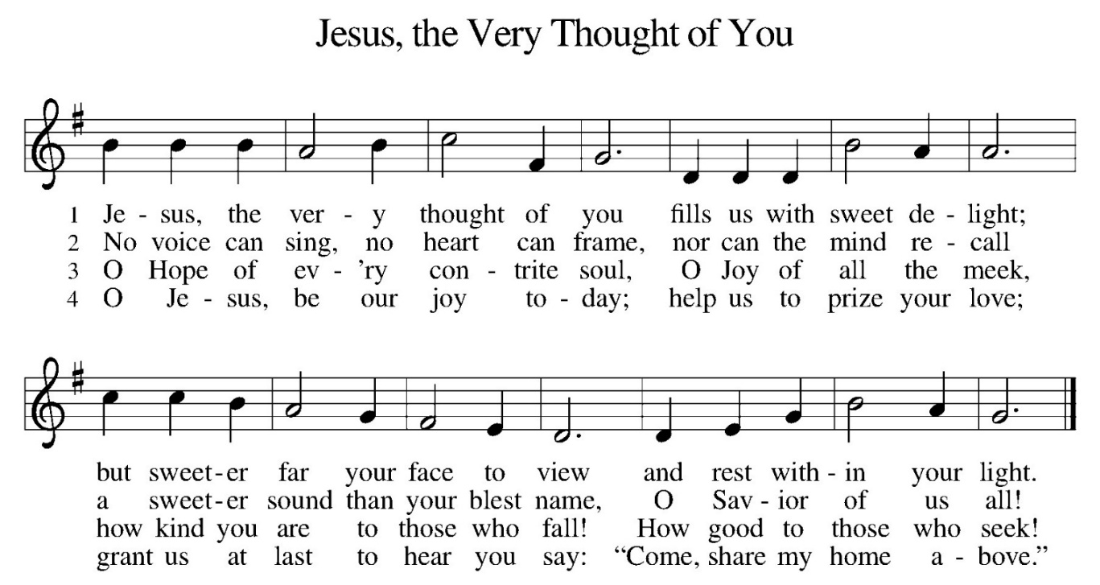
Offertory Prayer

God of creation,
you send rain and the earth springs forth abundantly.
All blessings are from you;
make us generous with what we have.
Use our gifts, our abilities, and our hearts
in service to you and in love to our neighbors,
today and always. Amen.

The Great Thanksgiving

The Lord be with you.

And also with you.

Lift up your hearts.

We lift them to the Lord.

Let us give thanks to the lord our God.

It is right to give our thanks and praise.

Preface
It is indeed right, our duty and our joy,
that we should at all times and in all places
give thanks and praise to you, almighty and merciful God,
through our Savior Jesus Christ;
who on this day overcame death and the grave,
and by his glorious resurrection opened to us the way of everlasting life.
And so, with all the choirs of angels,
with the church on earth and the hosts of heaven,
we praise your name and join their unending hymn:

Holy, Holy, Holy
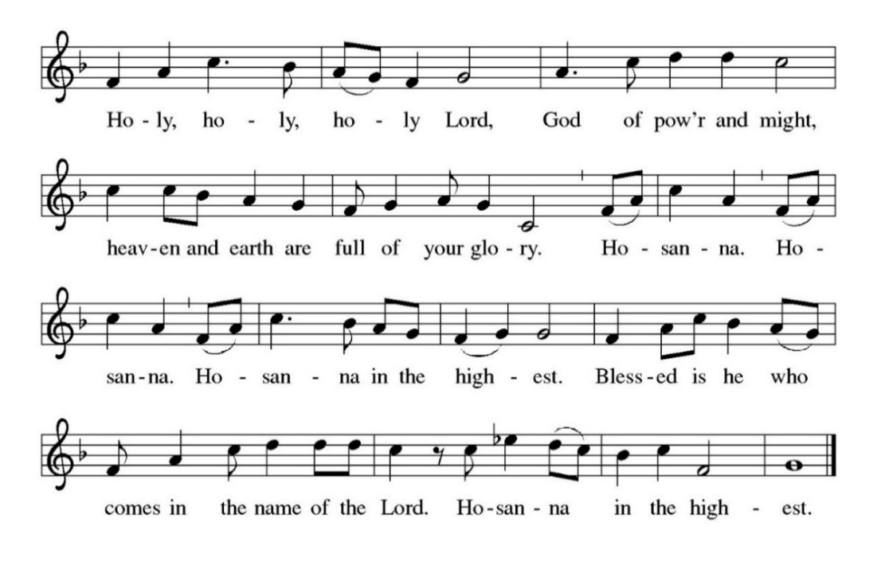

Holy, mighty, and merciful Lord,
heaven and earth are full of your glory.
In great love you sent to us Jesus, your Son,
who reached out to heal the sick and suffering,
who preached good news to the poor,
and who, on the cross, opened his arms to all.

In the night in which he was betrayed,
our Lord Jesus took bread, and gave thanks;
broke it, and gave it to his disciples, saying:
Take and eat; this is my body, given for you.
Do this for the remembrance of me.

Again, after supper, he took the cup, gave thanks,
and gave it for all to drink, saying:
This cup is the new covenant in my blood,
shed for you and for all people for the forgiveness of sin.
Do this for the remembrance of me.

Remembering, therefore, his death, resurrection, and ascension,
we await his coming in glory.

Pour out upon us the Spirit of your love, O Lord,
and unite the wills of all who share this heavenly food,
the body and blood of Jesus Christ, our Lord;
to whom, with you and the Holy Spirit,
be all honor and glory, now and forever. Amen.

Lord, remember us in your kingdom and teach us to pray.

The Lord’s Prayer
Our Father, who art in heaven,
hallowed be thy name,
thy kingdom come, thy will be done,
on earth as it is in heaven.
Give us this day our daily bread;
and forgive us our trespasses,
as we forgive those who trespass against us;
and lead us not into temptation,
but deliver us from evil.
For thine is the kingdom, and
the power, and the glory, forever and ever. Amen.

Christ invites you to this table with the whole communion of saints.
All who are thirsty, all who are hungry, come!

Lamb of God
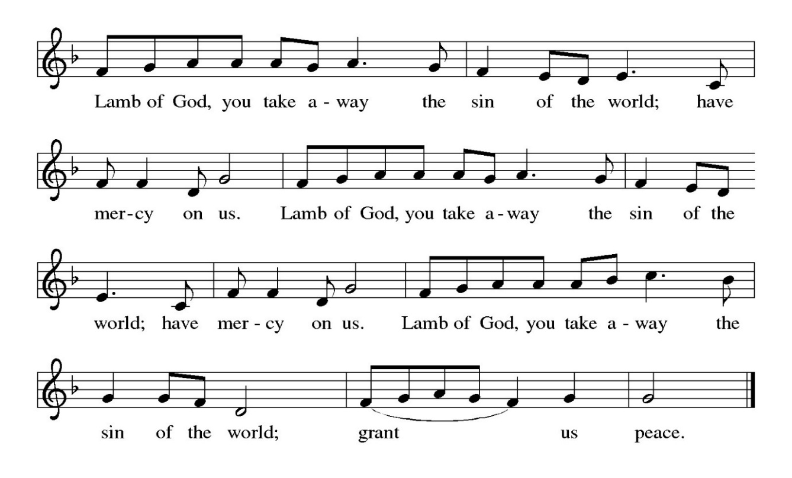

Communion Hymn: For the Bread Which You Have Broken No. 494

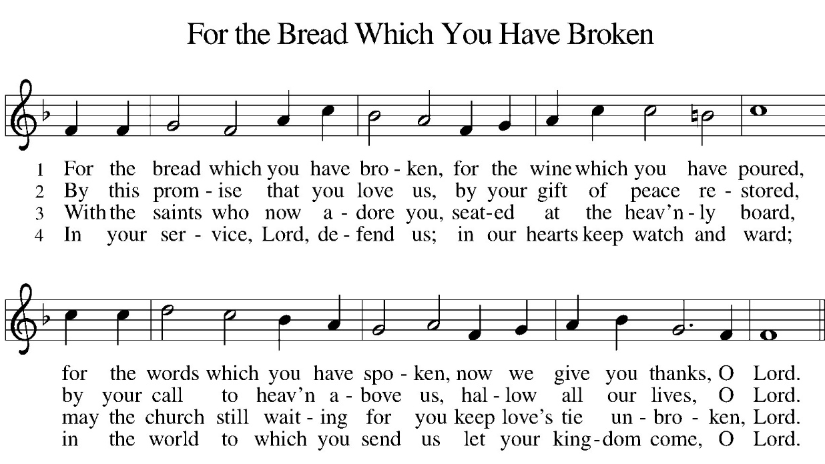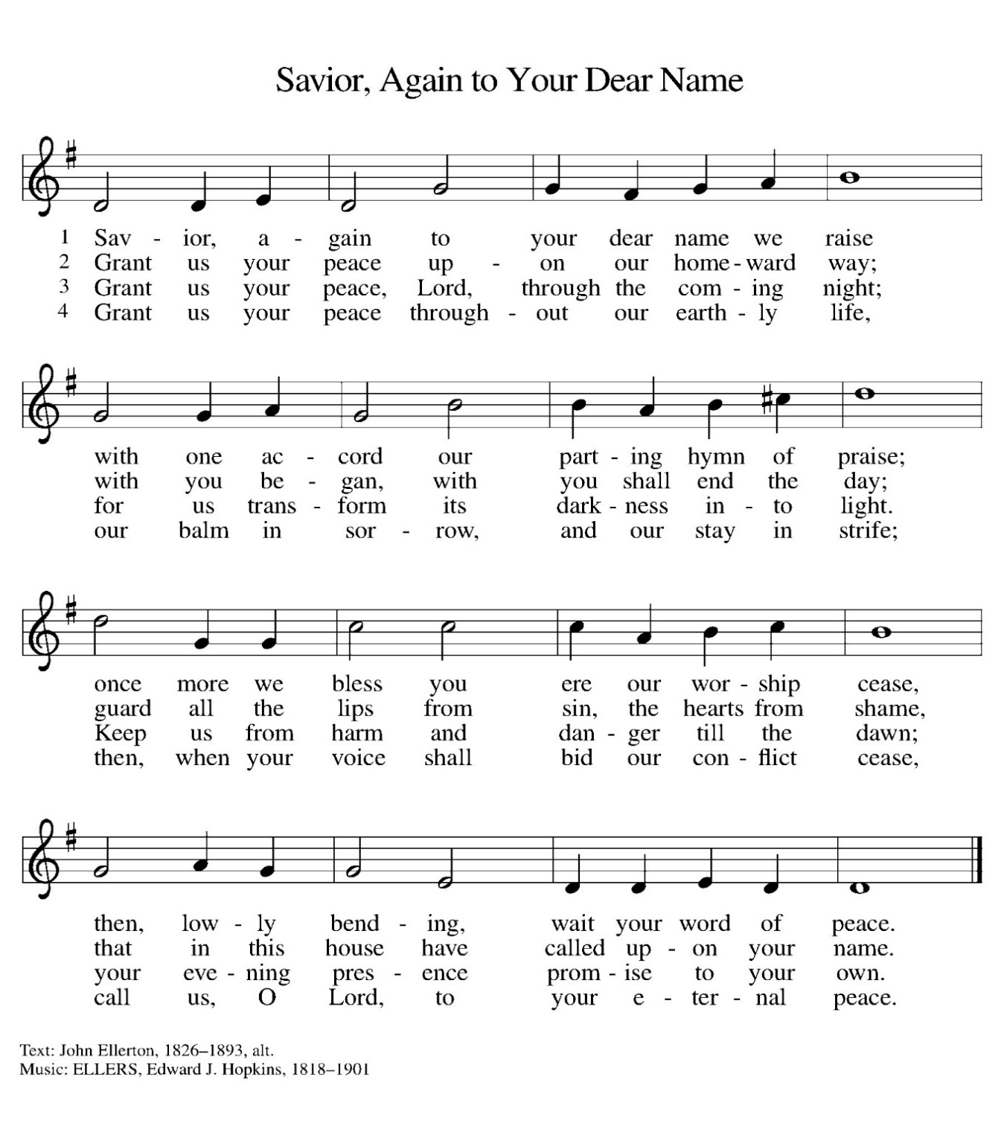
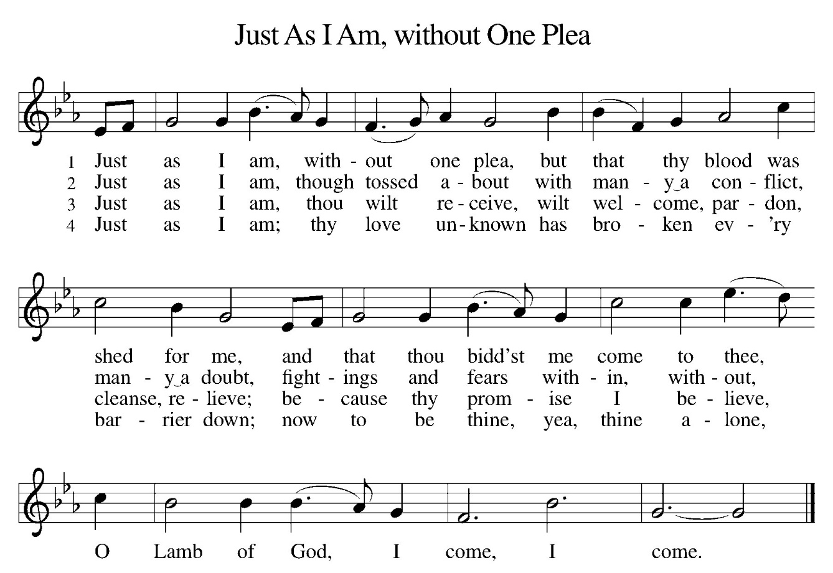
Table Blessing
May the body and blood of our Lord Jesus Christ strengthen you and keep you in his grace now and forever. Amen.

Prayer after Communion

Sustaining God,
with this bread and cup,
you nourish us with mercy and abundant life.
By your Spirit, send us from this table to serve a needy world.
Make us living signs of your liberation, healing, and love,
following the way of Jesus, in whose name we pray. Amen.

Blessing

The God of love
draw you into full accord and one mind,
in the body of Christ Jesus. Amen.

The God of hope
grant you strength and joy in all circumstances
through the interceding of the Spirit. Amen.

The God of grace bless you now and forever. Amen.
Closing Hymn: Lift High the Cross 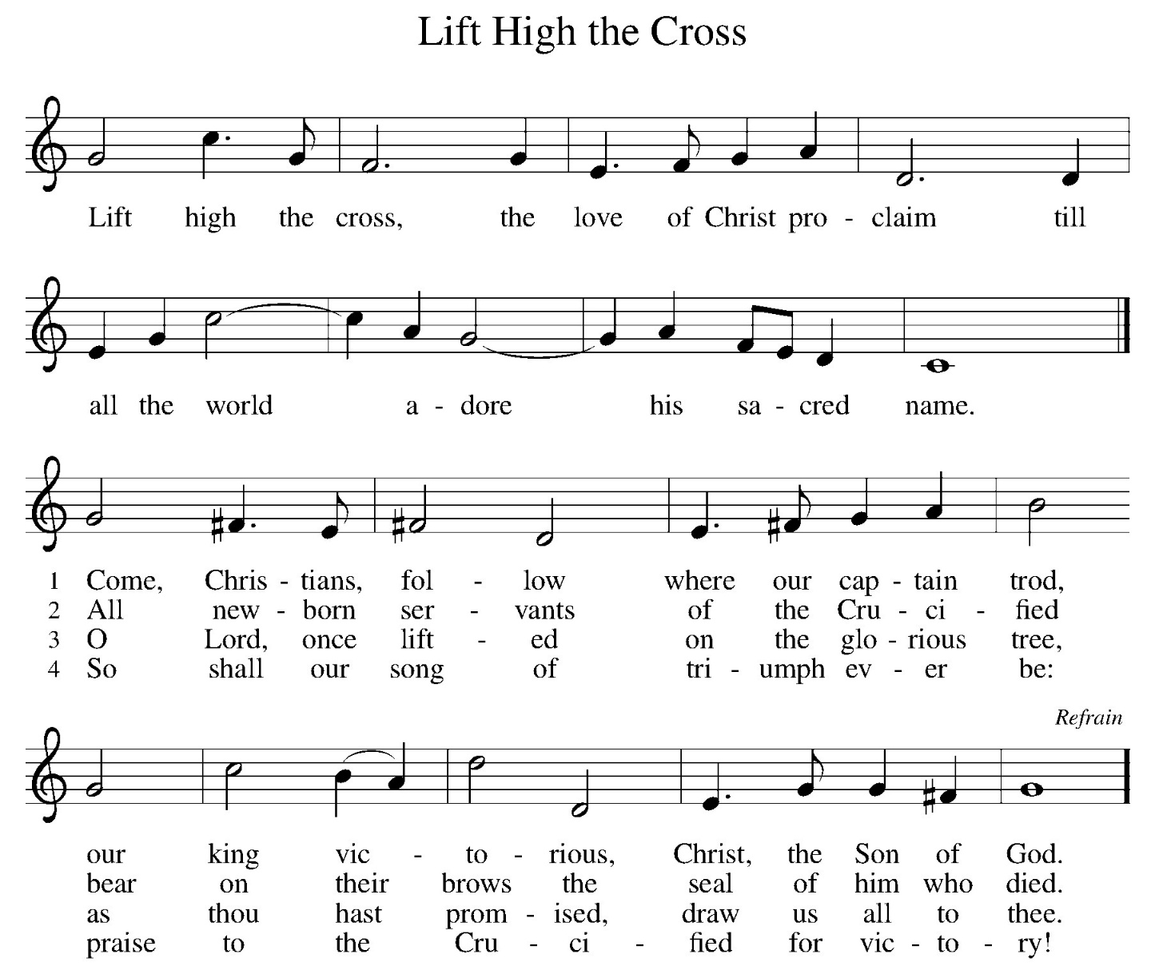

Dismissal
Go out in joy. Be led forth in peace.
Thanks be to God.

Postlude
Copyright © 2024 Augsburg Fortress. All rights reserved. Reprinted by permission under Augsburg Fortress Liturgies Annual License #SAS008914. New Revised Standard Version Bible, Copyright © 1989, Division of Christian Education of the National Council of the Churches of Christ in the United States of America. Used by permission. All rights reserved. Revised Common Lectionary, Copyright © 1992 Consultation on Common Texts, admin Augsburg Fortress. Used by permission. One License Licensing Permission. Reprinted/Streamed with Permission under One License #A-723716. All rights reserved. ©ChurchArt Online

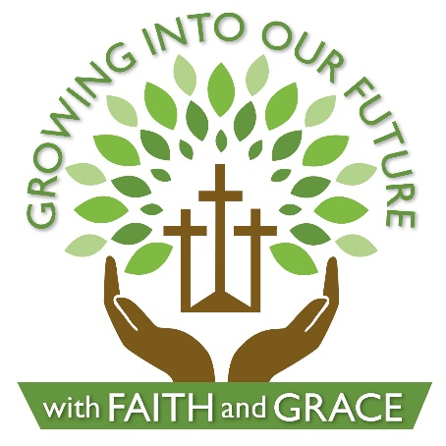
AT WORSHIP THIS MORNING:

At 9:15…

Preaching: Bishop Daniel Beaudoin
Presiding: Pastor Jen Herrmann
Lectors: Guy Miller
Communion Assistant: Bishop Daniel Beaudoin
Ushers: Guy Miller, Mark Wiedenheft,
Chrissy Neilsen, Gary Lieb

Acolyte: Ryan Wiedenheft
Musician: Adele Hoffman
Musician: Will Coffman
Chime Players: Jim Bertsch, Carrie Killingsworth
Drew Killingsworth, Emma Killingsworth,
Shelby Koch, Zoe Koch, Sally Warner,
Pat Wiedenheft, Carlie Wiedenheft,
Ryan Wiedenheft, Tyler Wiedenheft

September Altar Committee: Sally Warner & Bonnie Lieb

PRAYER CONCERNS

To congregations of all faith celebrating anniversaries in places of worship; FAITH members, including Mary Ann Neidler; the people of Grace, Castalia and their interim pastor; Project Share, helping people of need in Margaretta township.

Pastor Jen can be contacted at 419-822-7630 or jen.herrmann@gmail.com

OFFERING PLATES are in both entryways by the bulletins. If you forgot to put your offering as you came in, an usher or pastor can help you find the plates after service.

ATTENDANCE: September 6th 51 + 30 = 81

OUR RESPONSE TO GOD’S GOODNESS:
General Fund -- $3,990.00
Building Improvements -- $40.00

THE ALTAR FLOWERS are given to the Glory of God from Larry & Pat Wiedenheft in celebration of Trinity’s 100th anniversary.

THE MEMORIAL FLOWERS are given to the Glory of God from Fred Wobser

CELEBRATION FLOWERS Congratulations on 100 wonderful years! We rejoice with you as you celebrate this incredible milestone and give thanks for a century of faithful ministry. It is our joy from our Congregation to celebrate with you. With Christian love, Your Friends at Zion Lutheran Church

This Week at Trinity

TODAY 100th Anniversary Service & Brunch 9:15 am

WEDNESDAY “We All Belong” (Narcotics Anon.) 7:00 pm
Crossroads 1:00 pm

THURSDAY Council Mtg. 7:00 pm

SATURDAY “We All Belong” (Narcotics Anon.) 11:00 am

SUNDAY Communion Service 8:00 am & 10:30am
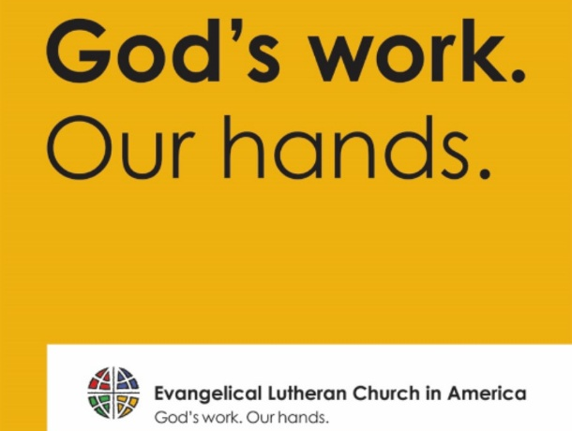

Thank you for your health kit contributions to Lutheran World Relief. We assembled last Sunday for “God’s Work, Our Hands” and had over 20 volunteers and we were finished quickly. We collected and assembled 138 kits that will be shipped in October. We are still collecting funds for shipping cost. Any donation is greatly appreciated -- mark your envelope “Health Kits.”

We are so glad you joined us to celebrate today. We are grateful for Bishop Daniel Beaudoin from the Northwest Ohio Synod for bringing the good news to us and rejoicing with us. A portion of today's offering that day will be given to the NWOS Annual Fund which supports local mission here in our synod. Brunch for those who signed up will be in the basement fellowship hall after worship.

Before you leave today, be sure to stop in the Gathering Room upstairs. There are cookies! We'd love to have a photo of you for our anniversary book, so stop in at the photo booth! (We will make 4x6 prints to be sent to you) You can buy a 100th Anniversary Christmas Ornament or Magnet for $10. You can check out the new archive room for history of our congregation and sign your name to our register for the day.

